Here is a list of frequently asked questions with reference to the Easy Duplicate FinderTM application and its usage –

I think I have a lot of duplicates. Is Easy Duplicate Finder™ the right program to deal with them?

If you want to find and remove exact duplicates, then Easy Duplicate Finder™ is for you. With the help of this program, you will be able to manage duplicate documents, photos, songs, videos, emails and more. There are lots of different options and scan methods that guarantee accurate results and make the search quick and easy.

However, if you are looking for a program to manage your photos, we suggest that you try [**Duplicate Photo Cleaner**](https://www.duplicatephotocleaner.com/)**TM** alongside Easy Duplicate Finder™. While Easy Duplicate Finder™ is great for finding exact copies of your photos, Duplicate Photo Cleaner can detect similar images of the same subject. This feature is ideal for those who have a large image library and want to get rid of poor-quality shots quickly.

How do I install Easy Duplicate FinderTM on a Windows PC?

**Tip:** For more information, refer to **Downloading the EDF Application Installer** section

What is the best way to scan my computer for duplicate files?

With Easy Duplicate Finder™, you can find and delete duplicate files in just a few clicks. Here is how:

1. Open Easy Duplicate Finder™ and drop target folders that you intend to include in the scan into the left easel. You can also click on "Add folders" and select folders without dragging and dropping by clicking this easel if you are adding the first folder in this easel. After you have added the first folder, to add more folders click the green Add button just above your first folder entry.
2. Similarly, you can add folders that you intend to exclude from this scan by specifying them in the right easel.
3. Specify scan parameters as per your requirements and click on the green Start Scan button to start the scan.
4. When Easy Duplicate Finder™ finishes the scan, you can utilize the Scan Summary page to view a summary of the scan. Then you can click the **Auto Remove** button to automatically remove the identified duplicates or you can click on the **Manual Review** button to examine the scan results on the following Scan Result Details page which is displayed after you click this button.
5. Click on **Manage Duplicates** button and select the **Delete** button from the select menu that opens when you click the **Manage Duplicates** button, then tell the program to put the duplicates in the Recycle Bin or Trash.

In what languages is Easy Duplicate Finder™ available?

Easy Duplicate Finder™ is available in English, German, Portuguese, Spanish, French, Italian, Turkish, Japanese, Chinese (Simplified), Ukrainian and Russian.

What is the difference between Easy Duplicate Finder™ & Duplicate Photo Cleaner™?

Both Easy Duplicate Finder™ and Duplicate Photo Cleaner™ are designed to find and delete duplicate files. The main difference between these two apps is that Easy Duplicate Finder™ works with duplicates of all file types, whereas Duplicate Photo Cleaner™ works with images only. In addition to that, Easy Duplicate Finder™ can only find exact duplicates. Duplicate Photo Cleaner™ is different because it can detect both identical and similar images, such as resized and edited photos. It can also find photos in different formats (a .JPG file vs. a .PNG file, for example).

If you are having trouble choosing between Easy Duplicate Finder™ and Duplicate Photo Cleaner, ask yourself what types of duplicates you want to find. Easy Duplicate Finder™ is ideal if you want to delete duplicate documents, songs, photos, emails, and videos from your computer. But if all you want to do is organize your extensive image library, consider getting Duplicate Photo Cleaner. It will not only help you find and delete duplicate photos, but also let you easily sort through similar shots and decide which ones to keep and which to delete or move.

How does Easy Duplicate Finder find duplicates and pre-select the files to delete?

Easy Duplicate Finder's File Search mode uses the SHA256 algorithm to compare files. This algorithm compares the hash for each file. If several files have the same hash, then one file is considered an original and the rest are marked as duplicates.

Here is how the scan works:

1. EDF scans the folders specified by the user and compiles a list of files.
2. If the user applied any filters (size, file extension, etc.), the files from the list are filtered according to that.
3. Once the results have been filtered, EDF calculates the SHA256 hash for each file. Files that have the same hash are duplicates.
4. EDF groups the duplicates and assigns numbers to the files starting with #1, then it sorts the results.
5. The file that was assigned with #1 is considered the original and the rest are considered duplicates. Because the files are the same (they have the same hash), the File Search mode selects the original file randomly. You can always modify the selection with the help of the pencil button. For example, you can mark the oldest or the newest files as originals. There are lots of batch selection options, so make sure you check them out.

How do I install Easy Duplicate Finder on a Mac?

To install Easy Duplicate Finder™ application on a MacBook, perform the steps described below –

1. Open [**https://easyduplicatefinder.com**](https://easyduplicatefinder.com) in your default web browser and click on the **Download** button.
2. Double-click on the file you've just downloaded. A small window will appear

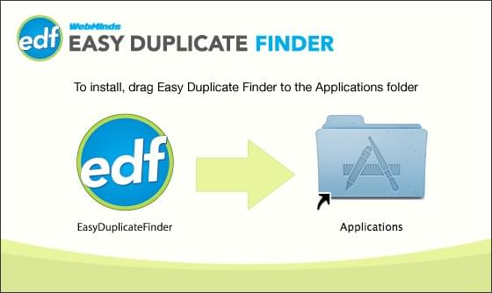

1. Drag and Drop the Easy Duplicate Finder icon in the Applications folder
2. Close the window
3. Go to the Applications folder or to the Launchpad and launch Easy Duplicate Finder from there
4. When you open Easy Duplicate Finder for the first time, your Mac may ask you if you are sure you want to open Easy Duplicate Finder. Click Open to launch the app.

Is there a portable version of Easy Duplicate Finder?

Yes. You can download it from the [**Version History**](https://www.easyduplicatefinder.com/history.html) page.

Why isn't there a special portable version for Mac?

That's because all Mac software is portable - you can run a .dmg file from any drive, including a USB thumb drive. Simply download the Mac version of the program and enjoy your portable Easy Duplicate Finder for Mac!

How does Easy Duplicate Finder decide which files are the originals and which are the duplicates?

I've just installed Easy Duplicate Finder on my Mac and I'm getting lots of security pop-ups. Why is that?

Mac OS X Mojave has enhanced security when it comes to third-party applications. That's why it will display popups like this one and ask you to allow access to Finder and other apps like iTunes and Photos:

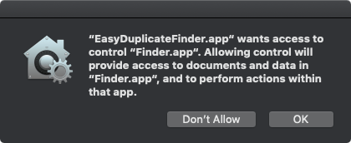

* The easiest way to stop these popups is to give EDF full disk access. Here is how:
* Open System Preferences, go to Security & Privacy, click on the padlock icon, and enter your system password to be able to make changes to the settings.
* Click on the Privacy tab. In the left-hand sidebar, scroll down to the Full Disk Access section (it looks like an ordinary folder)

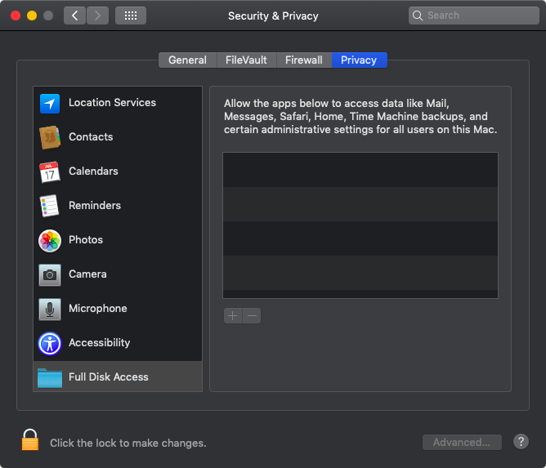

* Drag & drop Easy Duplicate Finder from the Applications folder to the "Allow" window or click on the "+" sign, browse to EDF, and grant it full disk access.

What are the trial version limitations?

Easy Duplicate Finder's trial version provides unlimited scanning and lets you manage 10 groups of duplicate files. After that, file management options become locked and the scanning remains available.

However, if you register for the Premium Free Trial, then you can add 20 more groups to your account.

**Reference:** For more information, refer to the **Limitations of Utilizing an Unregistered EDF Application in Trial Mode** section.

**Reference:** For more information, refer to the **Getting the Premium Free Trial** chapter.

I'm trying to register Easy Duplicate Finder™, but it's not working. Can you help?

There are a few things that may prevent the activation of the product, including:

* Your UAC (User Account Control) settings in Windows Vista, Windows 7, Windows 8 and Windows 10. When that's the case, simply close Easy Duplicate Finder™, then right-click on its shortcut on your desktop and select "Run as administrator". Then proceed to register the program.
* Your firewall or anti-virus programs may be preventing changes to your computer. Even ones you want to make such as registering your product. Try disabling your security software temporarily and proceed with product registration.

My MacBook is not connected to the Internet. Is there a way to activate Easy Duplicate Finder offline?

Follow these steps to activate Easy Duplicate Finder on your MacBook that's not connected to the Internet:

1. Purchase a license key and install Easy Duplicate Finder on your computer.
2. Open Easy Duplicate Finder, click on the hamburger menu and go to "About".
3. Copy the product key from the popup that appears.
4. Go to this page and open a support ticket. Make sure you send both your product key and your license key to the Support Team.
5. Our Support Team will generate activation data for your copy of Easy Duplicate Finder and email it to you.
6. Copy the activation data from the email, save it as a text file and put the file on a flash drive.
7. Connect the flash drive to your offline computer, open the text file with the activation data, select all of it and copy it. Important: don't paste it anywhere at this point!
8. Open Easy Duplicate Finder. If you have valid activation data and if you've followed these steps correctly, your copy of Easy Duplicate Finder will become activated.

I want to install Easy Duplicate Finder™ on my new computer using my license key. How do I do that?

How do I upgrade to the latest version of Easy Duplicate Finder™?

Why is there an expiration date on my Easy Duplicate Finder™ license?

My system crashed and Easy Duplicate Finder™ got unregistered. How do I get my software up and running again?

I thought I had purchased a license for 3 computers, but it looks like I've purchased a single-PC license. Is there any way to upgrade my license for the price difference between the two?

How do I log into my account on easyduplicatefinder.com?

What is the EDF File Color Legend ?

I'm updating to Windows 10. Will your software continue to work?

I still use Windows XP on my computer. Is Easy Duplicate Finder compatible with it?

Can Easy Duplicate Finder find duplicate files in Dropbox and on Google Drive?

Why isn't there an Undo button in Google Drive and Dropbox scan modes?

Does Easy Duplicate Finder sync everything across my devices when I use the Google Drive and Dropbox scan modes?

Does Easy Duplicate Finder work with network drives?

Does Easy Duplicate Finder offer different options for viewing the duplicates at Step 3?

How can I make sure the program doesn't delete files that are not duplicates by mistake?

How do I search for duplicate files in just one folder?

Does Easy Duplicate Finder find files shared with me on Google Drive when I use the Google Drive scan mode?

How do I check which duplicates are pre-selected at Step 3 and modify the selection?

How do I sort duplicates by folder if I want to keep files in a particular folder?

How do I use the "Music Tags" mode to find duplicate songs?

Does EDF's Music Scan mode offer a way for me to delete low-quality duplicates songs in bulk?

How do I configure Easy Duplicate Finder™ to sync with my iTunes/iPhoto/Windows Media Player library?

I've scanned some folders for duplicates and got lots of results. Now I want to make sure I don't delete files from a specific folder and its subfolders. How do I do that?

Is there a way to use Easy Duplicate Finder to compare files against files in a specific folder? Or compare files in Folder A against files in Folder B?

What exactly does the Folder Comparison scan mode do?

What does the "Replace with Symbolic Link" duplicates file management option do?

Which email clients does Easy Duplicate Finder support?

What's the difference between the Email Mode and the Outlook Mode?

Which versions of Microsoft Outlook are supported?

How exactly does Easy Duplicate Finder detect duplicate emails?

How do I scan local Outlook folders on a Mac?

In Contacts Scan, what's the difference between the "Merge" and "Merge and delete" options?

Can I use Easy Duplicate Finder to find and delete files in the Windows.old folder after upgrading to Windows 10?

What is audio fingerprint music comparison technology and how do I use it?

Is there a way to filter the scan results and search for files?

What is EDF Monitor?

My Windows computer won't let me install Easy Duplicate Finder™. What to do?

I'm trying to install Easy Duplicate Finder on my Windows PC but it conflicts with another application. What to do?

I'm trying to drag & drop folders to scan but it's not working. Why is that?

Windows 10 keeps deleting Easy Duplicate Finder whenever I download it. Why is that and how can I prevent it?

Easy Duplicate Finder™ isn't detecting some files that I know are duplicates. Why is that?

Easy Duplicate Finder™ found lots of duplicates, but I can't delete them. Why is that?

I've accidentally deleted some files I need. What to do?

Why can't I select the "Keep files in this folder" option?

Why are some detected files marked "Read only" and is it safe to delete them?

I've just deleted duplicate iTunes songs, but iTunes still sees duplicate music. Why is that?

I'm trying to scan my MP3 player with Easy Duplicate Finder™ and it's not working.

I'm using the Music Scan mode and Easy Duplicate Finder is not detecting some duplicates. Why is that?

I want to scan a network drive with Easy Duplicate Finder but I can't add it to the scan. What to do?

I've updated Easy Duplicate Finder and now the program doesn't recognize my network drive.

I'm trying to use the Email Mode to find duplicate emails in Outlook but it's not working. What to do?

I'm trying to get Easy Duplicate Finder to find PST files using the Email Mode and nothing works.

I'm using the Outlook Mode to scan for duplicate Outlook emails but Easy Duplicate Finder hangs. What to do?

I'm having trouble activating Easy Duplicate Finder. What to do?

Why is the scan speed slower when performing scans on a network share?

How does network speed impact scan performance on network shares?

Can I improve the scan speed on a network share?

What is the "Cache file information" option, and how does it affect network share scanning?

How do I disable the "Cache file information" option in scan settings?

Are there any specific recommendations for network share scanning?

Does the scanning speed on network shares vary based on the file types being scanned?

Are there any other tips for improving network share scanning performance?